Aws Api

Amazon API Gateway Implementation
Amazon API Gateway is an AWS service for creating,
publishing, maintaining, monitoring, and securing
REST, HTTP, and WebSocket APIs at any scale.
Use case : Expose Lambda function as a public
REST API endpoint.
User API Gateway Lambda Response→ → →
Click create an API ---- click on Build REST API ----give
API Name ---- endpoint type --- create API
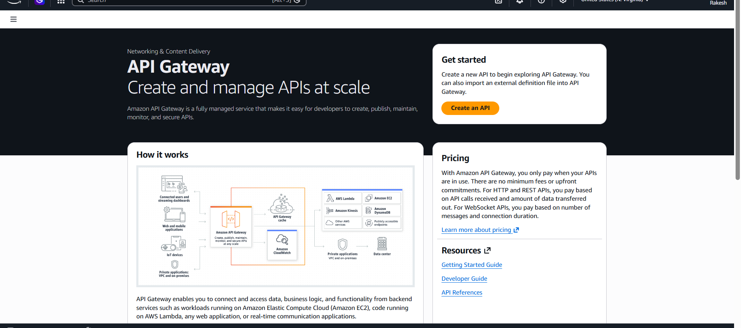
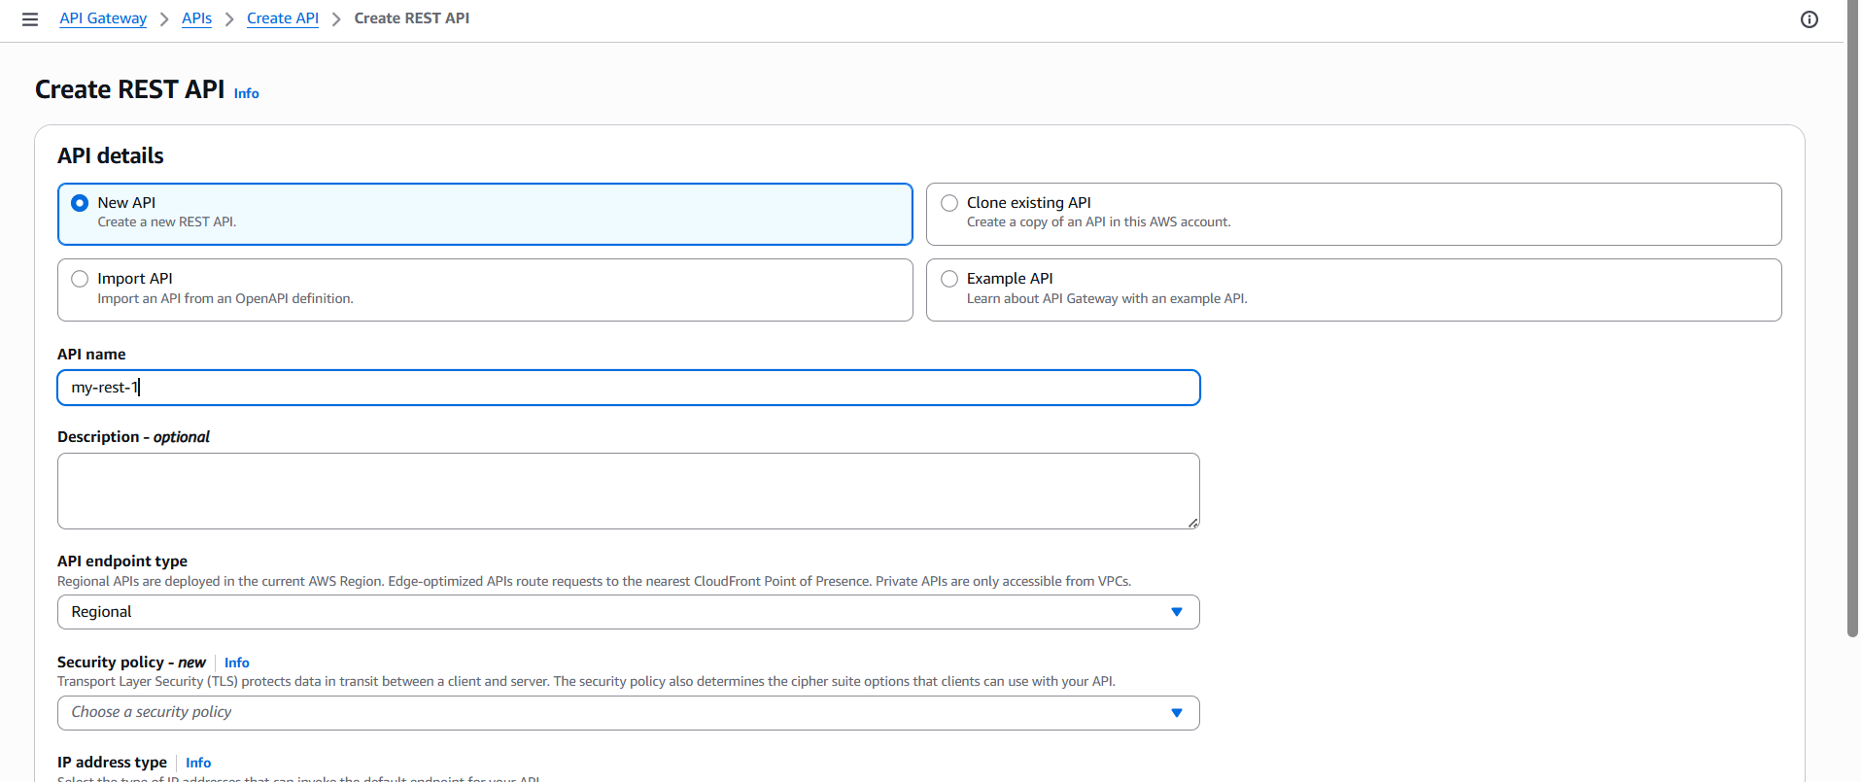

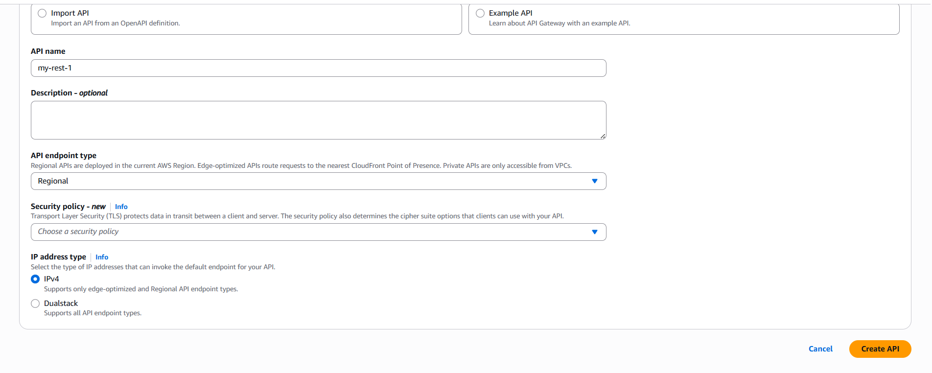
Create Resource :
Click Create Resource --- give Resource Name --- give
resource path ---click create resource
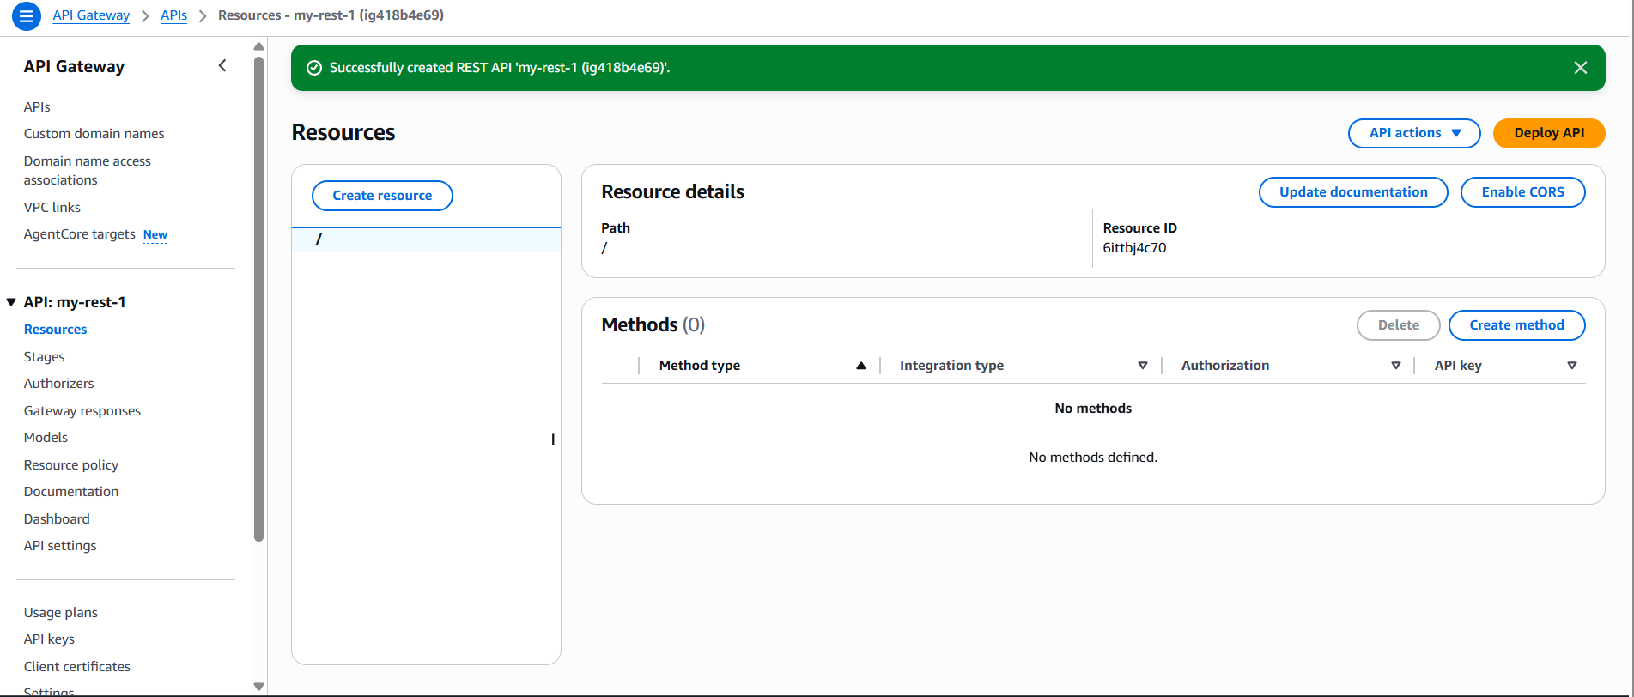
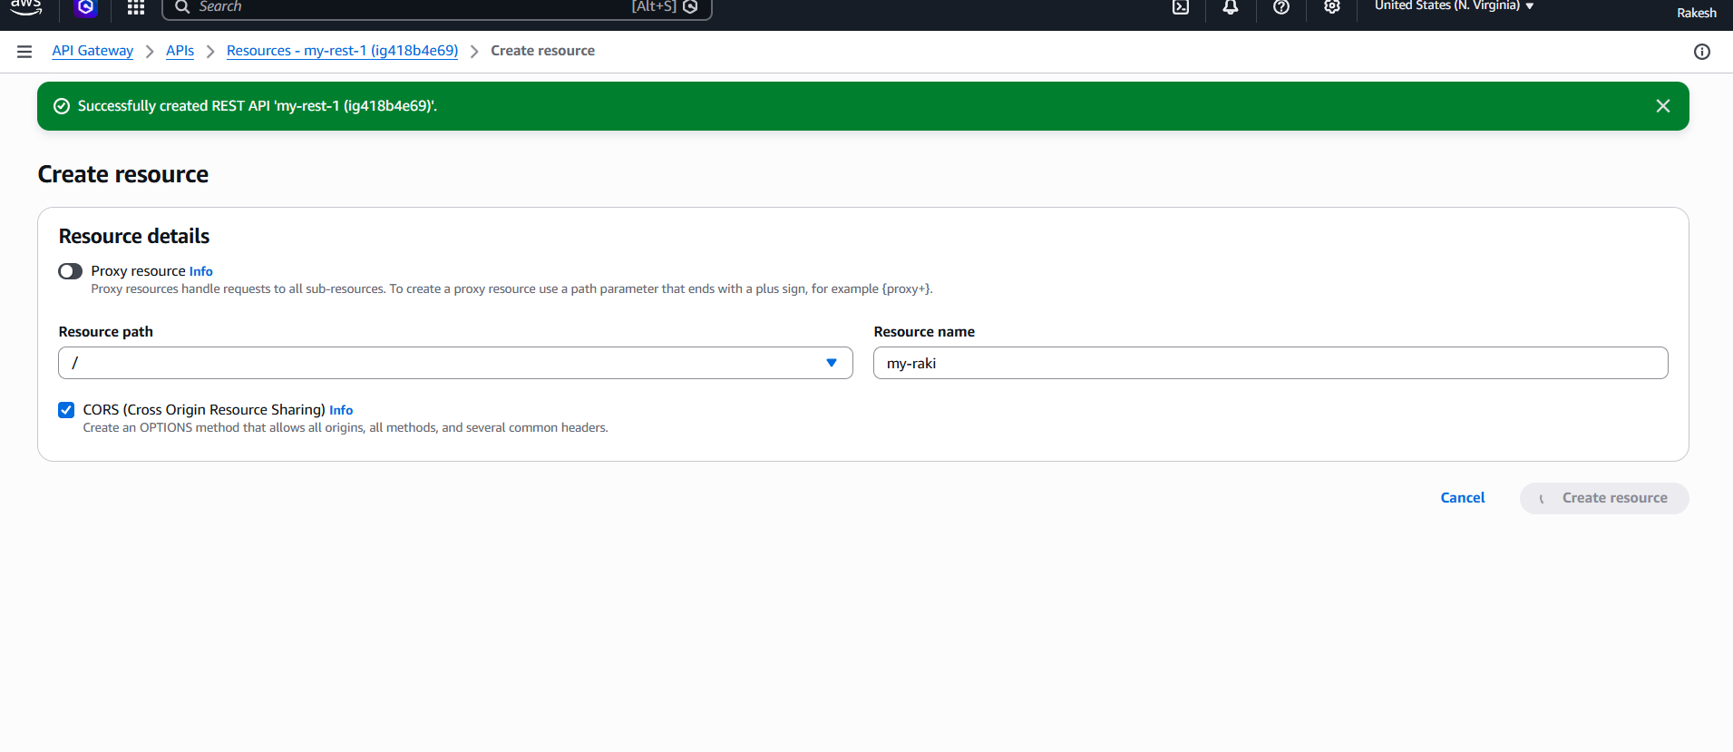
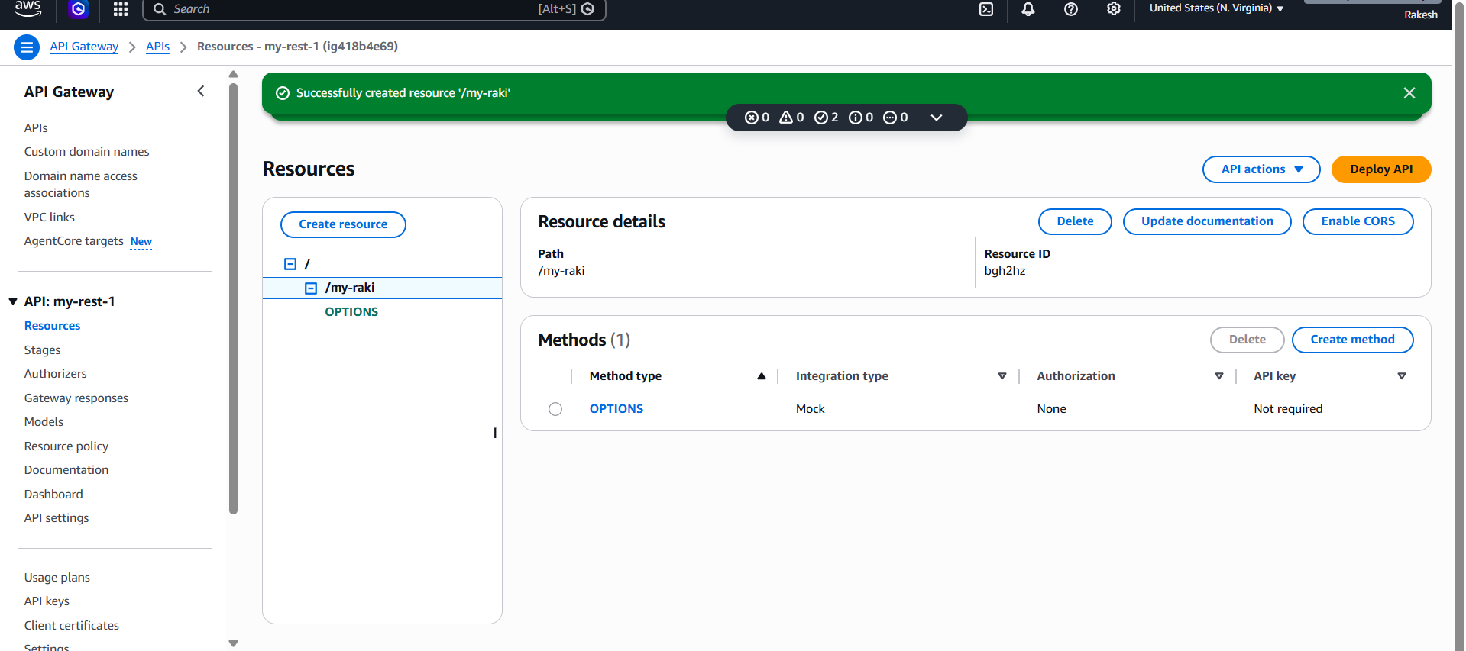

Create GET Method
Select / --Click Create Method -- Method Type :GET → Integration Type:Lambda
Function -- Enable Lambda Proxy Integration → Enter Lambda Function – Click Create Method
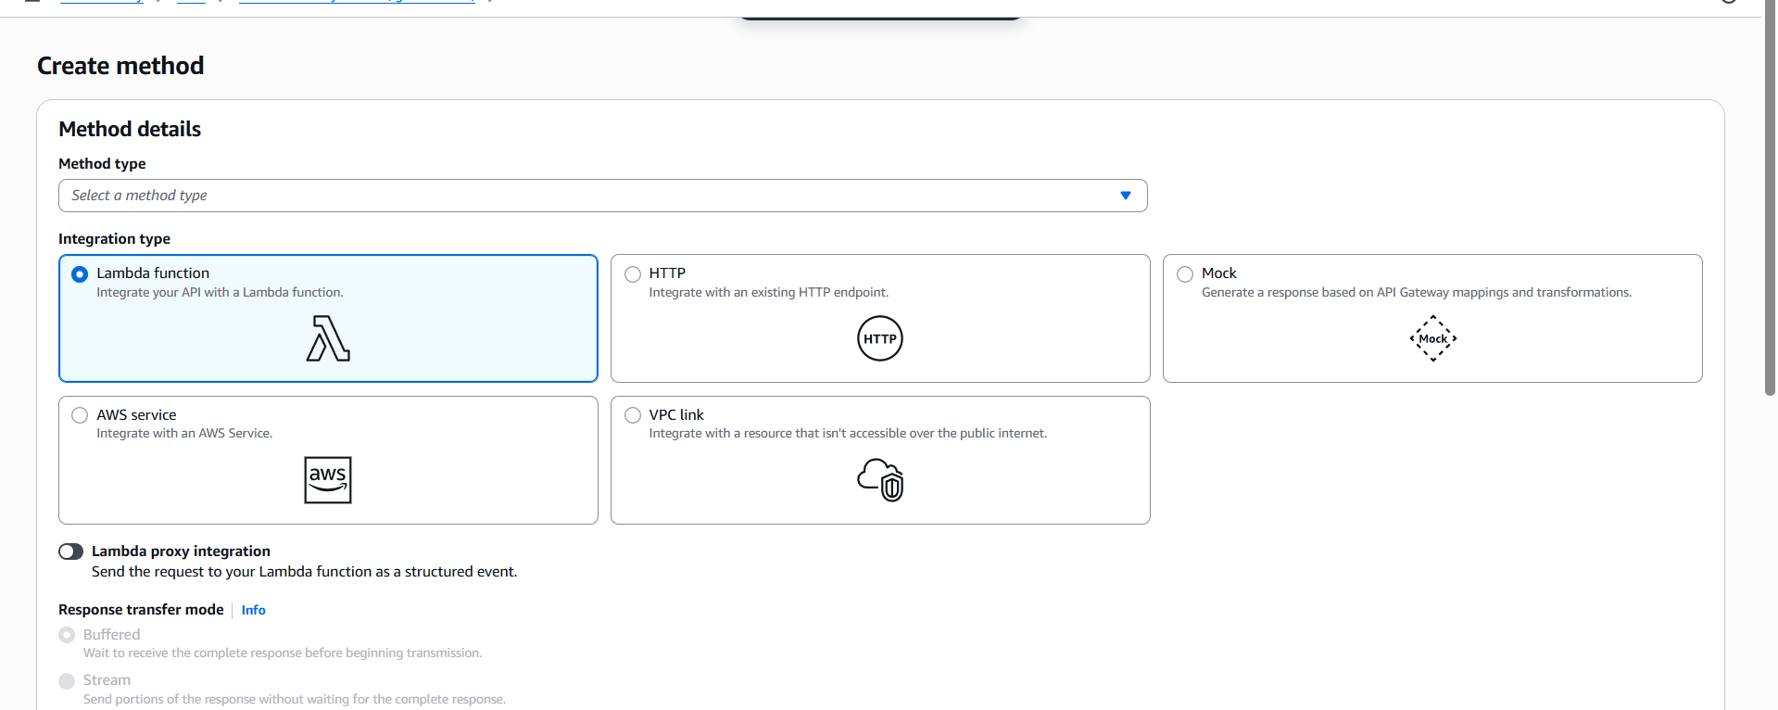

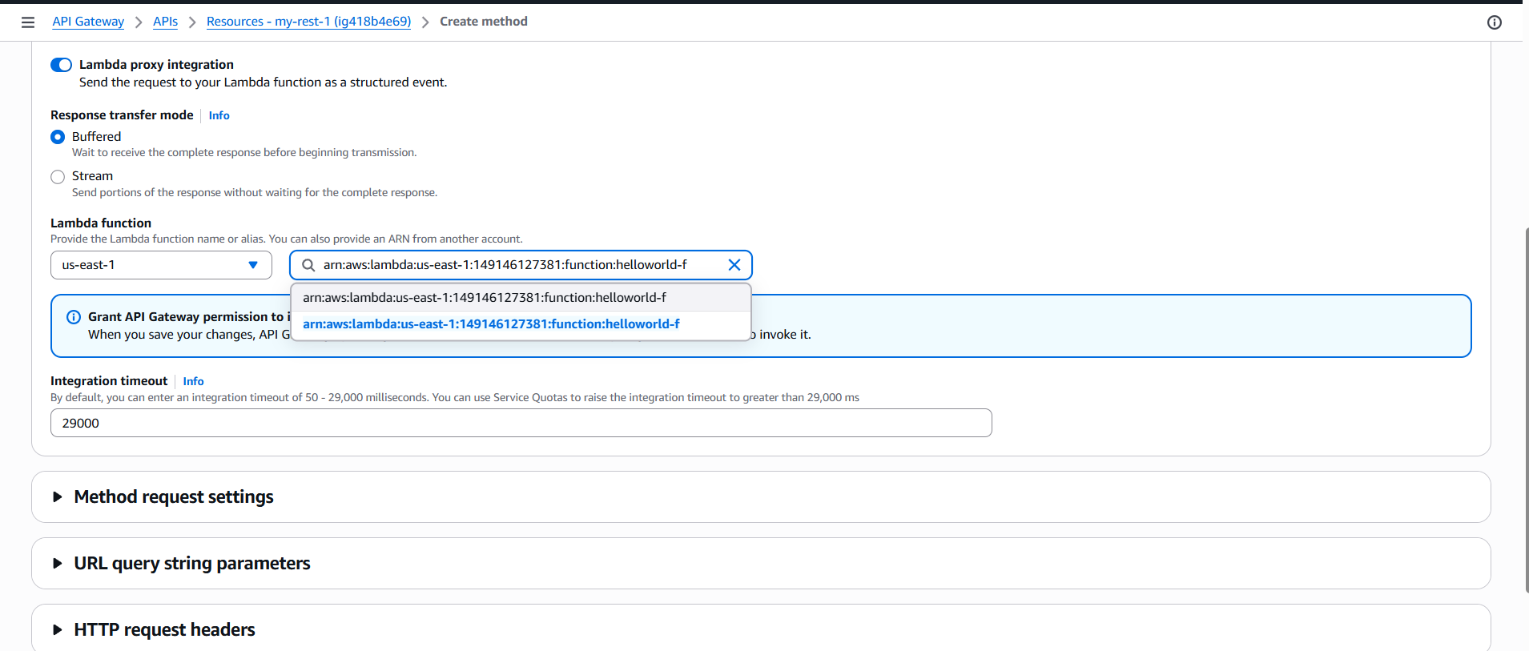

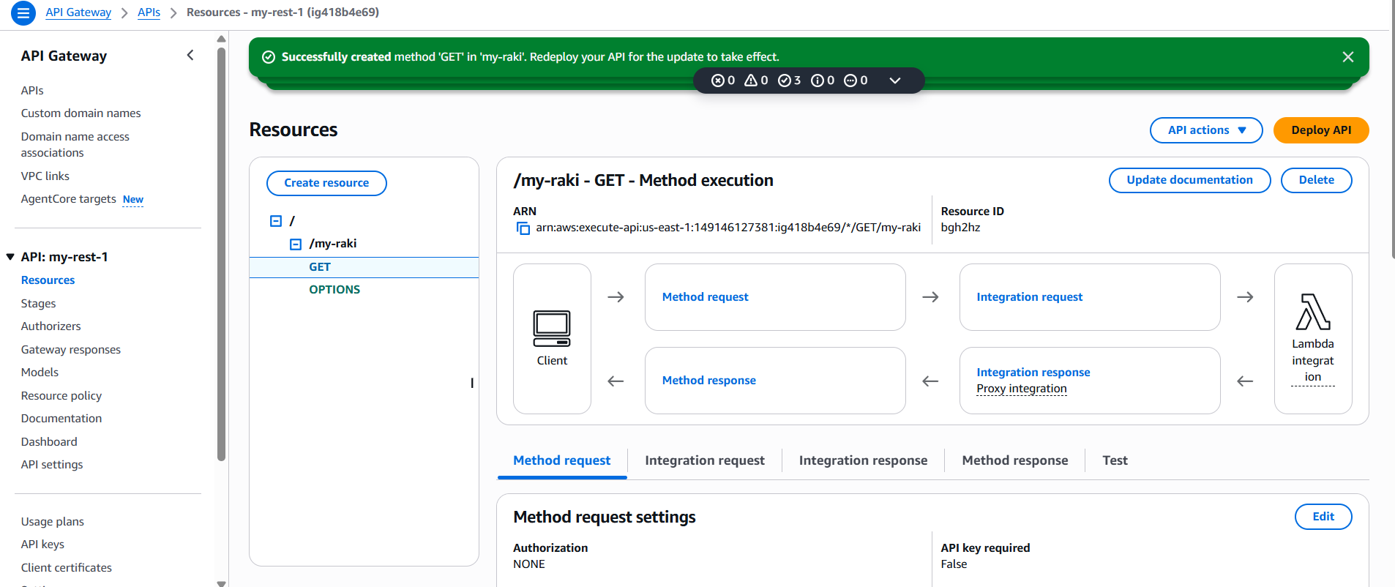
Deploy API
Click deploy API -- Stage name -- Click Deploy
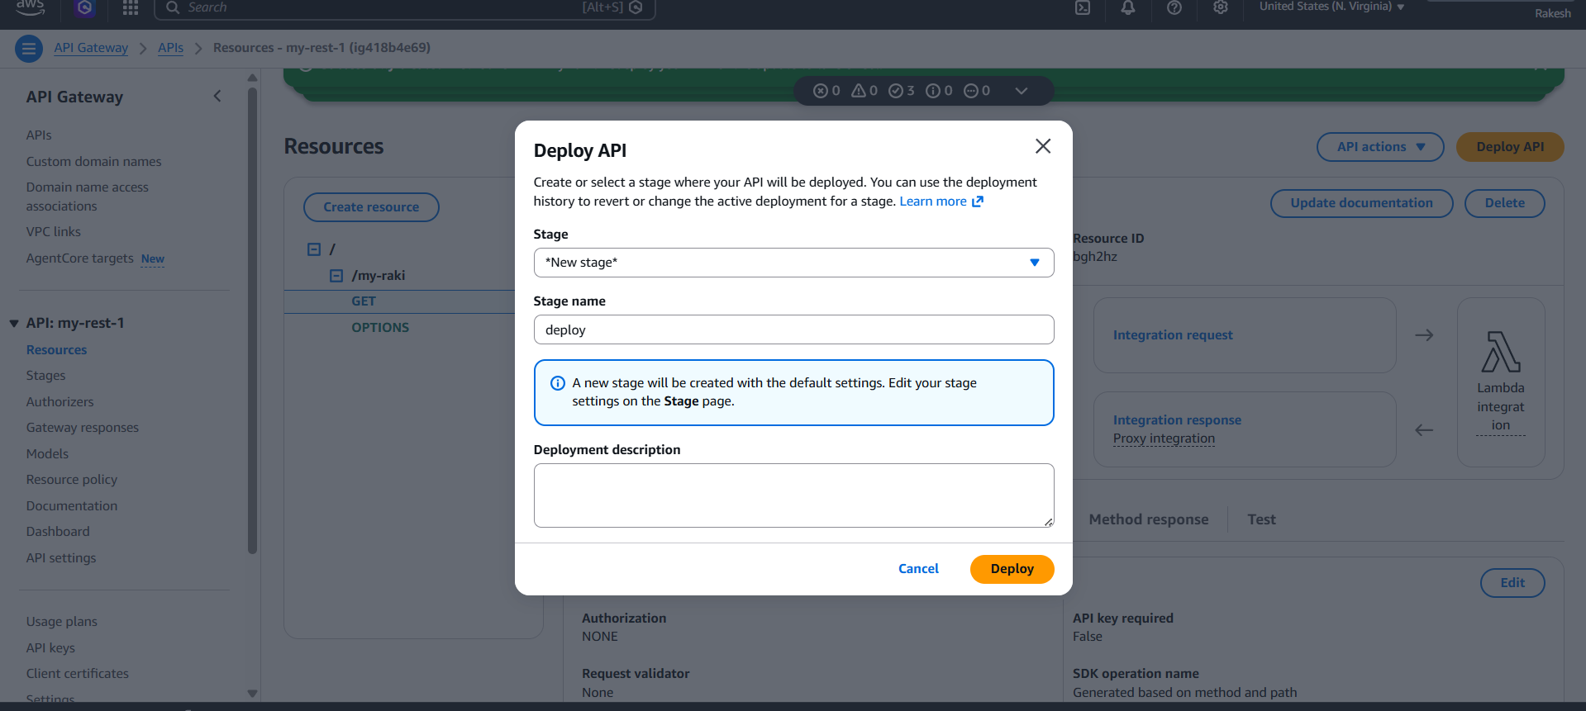
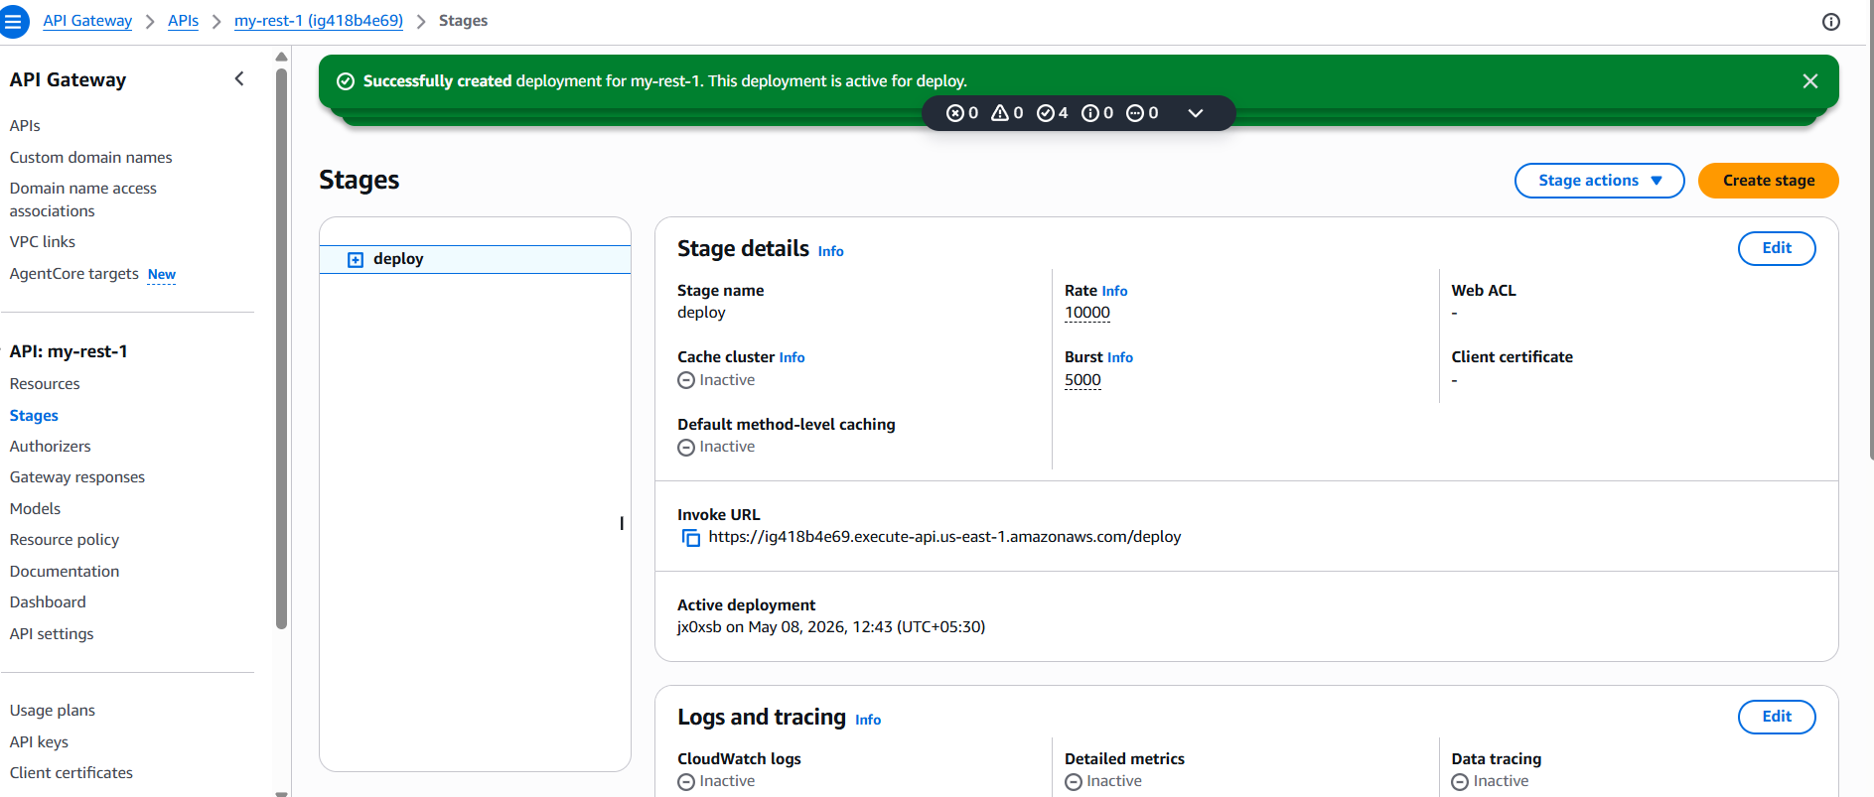
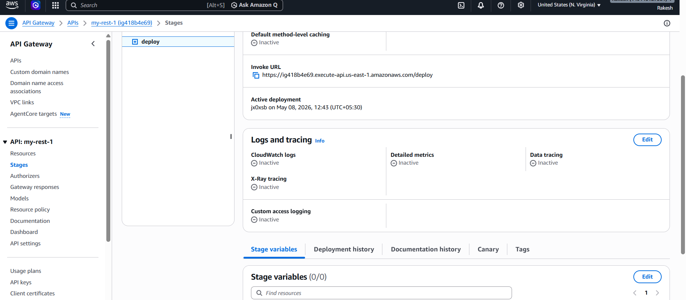

I have checked in browser and it worked fine
